ACCUFIRE THERMAL SIGHT

INCENDIS INC4-35
Product Specification

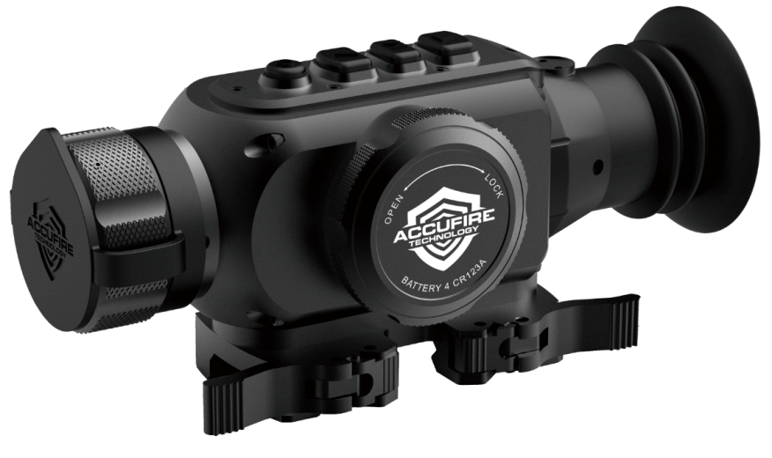
SPECIFICATIONS
SKU
Model
Microbolometer
Type |  | Uncooled
Resolution, pixels |  | 384x288
Pixel size, µm |  | 17
Frame rate, Hz |  | 50(PAL)/60(NTSC)
Optical characteristics
Magnification 1x
Digital zoom 2x,4x
Objective lens, mm |  | 35mm/F1.2
Horizontal field of view, degree |  | 10.7
Field of view, m at 100 m |  | 18.7
Exit pupil diameter,mm |  | 20
Eye relief, mm |  | 10
Detection range of people 1.8 m high,  m/yard, approx |  | 1000/1094
Recognition range of people 1.8 m high,  m/yard, approx |  | 500/547
Close-up range, m |  | 2
Display
Type OLED
Resolution, pixel |  | 1024x768
Operational characteristics
Power supply, V |  | 5-7.2
Battery type |  | 4×ICR16340/4×CR123A
External power supply |  | 5V(USB)
Operating time on a battery set (t=25℃), hour |  | 3+
Degree of protection (attachment / monocular), IP  code (IEC60529) | IP54
Operating temperature |  | -30℃~+50℃/-22℉~+122℉
Dimensions,mm/inch |  | 180×77×80/7.1×3.0×3.1
Weight(without batteries), kg/oz |  | 0.69/24.3

PACKAGE CONTENTS
- Incendis Thermal
- Eyepiece attachment
- Neoprene bag
- USB-C cable with Video-out
- USB one-in-four charging cable
- Certificate of inspection
- Lens cloth
- Warranty card
- 4 x Rechargeable CR123 Batteries (ICR16340)

FEATURES
- 384x288 pixel sensor size
- The device is mountable on any standard picatinny rail
- Thermal detection range: 1100 yards
- Display: OLED (1024x768 pixels)
- Can be used as a stand-alone thermal optic with independent reticle and forward of an optic tandem clip-on
- Any external battery can be used with the USB-C external power source
- USB-C interface with video output
- Three calibration modes, automatic calibration, manual calibration, and shutter calibration
- Three scene contrast presets
- 4 pseudo-color modes, including white hot, black hot, red tracker, and green
- Sustainable operation at temperatures from -22 °F to +122 °F
- Compact size
- Lightweight
EXTERNAL VIEW AND CONTROLS
Lens
Focusing Ring
USB-C Interface
Battery Cover
Eyepiece
ON/OFF Button
UP Button
MENU Button
DOWN Button
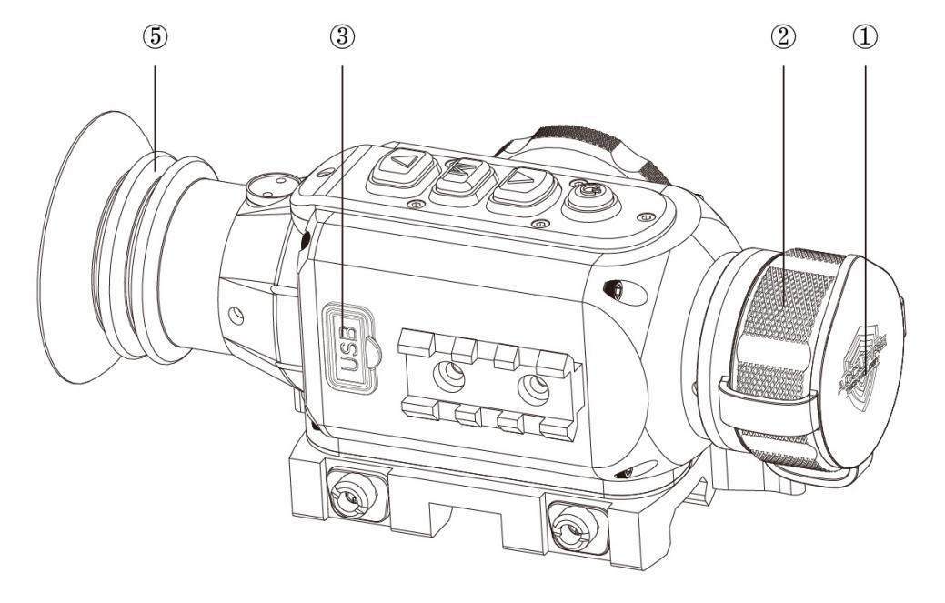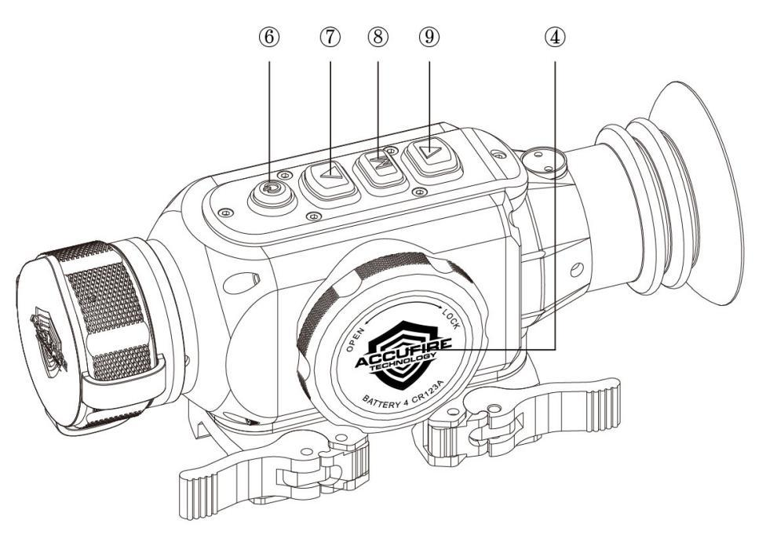

Buttons | First long press | Next long press | Short press | Menu operation
 |  |  |  | Short press | Long press
“ON/OFF” | Turn on the Incendis | Turn off the Incendis | Calibrate the Incendis | --- | ---
 |  | Display off | Display on
“UP” | --- | --- | Switch magnification | Switch menu option | ---
“Down” | --- | --- | Switch the pseudo-color mode | Switch menu option | ---
“MENU” | Functional menu display | --- | Switch the scene mode | Enter/exit menu/select | Cancel Menu w/o saving
Notes: When the Incendis is on, press the power button for a long time to display the off progress bar. Before finishing the progress bar, release the power button to cancel power off and enter into sleep mode; under the sleep mode, press any button for a short time to leave rest mode.

MENU / STATUS BAR ICONS:
Exit Hotpoint track
Screen brightness Factory reset
Calibration Automatic Shutter compensation
Scene compensation Shutter compensation manual
Video output Open the video output
White heat Black heat
Red heat Green heat
Auto power-off Auto sleep
Picture contrast Picture brightness
Cursor/screen adjustment X-axis adjustment
Y-axis adjustment save and exit
Cursor position selection Reticle On/Off switch
Reticle adjustment Image enhancement
High brightness Natural brightness
Notes: When the Incendis is simultaneously used with a traditional riflescope, select the cursor/screen adjustment to adjust the screen’s central position and make it consistent with the reticle of your riflescope (NOTE: screen adjustment does not alter reticle sight-in); when the Incendis is used as a stand-alone optic, turn on the reticle; the screen displays the reticle, select the reticle adjustment, and adjust the reticle using the X & Y axis adjustments.
GUIDELINES FOR OPERATION
To maintain stable operation of the product, please observe the following rules:
- Before use, ensure that the device is installed and adjusted (levers should engage resistance approximately 20 degrees before close position);
- Batteries will need to be charged before first use
- To insure best return to zero mounting, when mounting, (1) attach the unit to the same rail platform as previously attached (2) shift the unit forward if there is any play in the rail section where mounted (3) shift the lever to close position nearest to the eye objective first before shifting second lever near the front into place.
- When unit is put into storage, remove the batteries;
- When cleaning the non-optical surface of the Incendis, do not wipe it with chemical solvents. It is better to wipe the shell by using clean, soft, and dried cloth
- Any attempt to dismantle or maintain the Incendis will void the warranty.

BATTERY INSTALLATION
Rotate the battery compartment cover counterclockwise to open the battery compartment, and install 4 CR123A or 4 ICR16340 batteries. Please install batteries correctly according to positive and negative terminals, replace the battery cover, and rotate it in clockwise until it is tightened.
After the Incendis is powered on, life of the batteries is shown at the top the screen. There are 6 battery level states, including fully charged , 80% charged , 50% Charged , 25% Charged , 10% Charged , and low battery .
Note: Rechargeable batteries will not be properly indicated in the battery indicator symbol
EXTERNAL POWER SUPPLY
Open the USB-C rubber plug , insert the USB cable into the USB-C interface, and insert any 5V USB mobile power to another USB interface of the USB cable to supply power.
Video output
Open the USB-C rubber plug , insert the USB cable into the USB-C interface, and insert another end of the USB cable into the display that supports this interface. Recording devices must have independent power supplies.

OPERATION

Start and setup
Leave the rubber lens cover on, press “ON/OFF” button until the Accufire logo appears on the screen; the battery indicator will disappear 3 seconds later.
- Image calibration; see details in “image calibration” description in the MENU;
- Remove the lens cover, rotate the optical focusing ring until the image is clear

Adjust magnification
Short press “UP” button to switch the device magnification between 1x, 2x, and 4x in order.

Switch the pseudo-color mode
Short press “DOWN” button to switch the pseudo-color mode between white hot, black hot, red tracker, and green in order.

Switch the scene mode
Short press “MENU” button to switch the scene mode between scene settings. These settings may be individually adjusted through the menu when selected.

MENU
Long press “MENU” button to make the device enter into the first-level menu mode; in the first-level menu mode, long press the button to exit/cancel the menu mode and return to the main screen; in the first-level menu mode, short press the button or the button to select menu setting sub menus or options.

Exit Menu
Press the button or the button for a short time to select the icon , exit the MENU, and return to the main menu.

Screen brightness
Set up the screen brightness which includes 10 grades from 1 to 10; short press the button or the button to select the icon , short press the button to enter into the screen brightness setup, short press the button or the button to select the screen brightness, and short press the button ; after finishing setup, long press the button to exit the current setup and return to the first-level menu.
The compensation mode
Set up the compensation mode, including automatic compensation “Aub”, scene compensation and shutter compensation. Short press the button or the button to select the icon , short press the button to enter into the compensation mode setup, short press the button or the button to switch the mode selection, and short press the button for setup; after finishing setup, long press the button to exit the current setup to return the first-level menu.
- Automatic compensation
Start up, remove the rubber lens cover, select the automatic compensation mode, save and exit. The software algorithm will be automatically operated to calculate compensation.
- Shutter compensation manual
Start up, remove the rubber lens cover, select the shutter compensation mode, save and exit, and short press “ON/OFF” button to execute the compensation.
- Scene compensation
Start up, remove the rubber lens cover, select the scene compensation mode, save and exit, and short press “ON/OFF” button to execute the compensation. Scene compensation deactivates the physical shutter in the unit.

Video output
Open/close video output; when video output is opened, videos are routed to the display of the external video interface. Short press the button or the button for to select the icon, short press the button to start setup, short press the button or the button to select on or off, short press the button for confirmation, start up the operation, long press the button to exit the current setup and return to the first-level menu, and display the icon will be displayed at the lower right of the screen.
Hotpoint track
Open/close hotpoint track; when using hotpoint track, the cross cursor will track the highest point of temperature in the display.
Short press the button or the button to select the icon, short press the button to enter into setup, short press the button or the button to select on or off, short press the button for confirmation, long press the button to exit the current setup and return to the first-level menu.
Auto sleep:
Auto sleep can be turned on and the amount of time until auto sleep can be set up. No auto sleep is displayed as “Nona”. Time to start auto sleep can be set up as 5min, 10min, and 15min. After sleeping, press any button to wake the sleep.
Short press the button or the button to select the icon, short press the button to enter into setup, short press the button or the button to select the mode, short press the button for confirmation, and long press the button to exit the current setup and return to the first-level menu.
Auto power off
Auto power off can be turned on and the amount of time until auto power off can be set up; no auto power off is displayed as “Nona”. Time in auto power off can be set up as 15min, 30min, and 60min.
Short press the button or the button to select the icon, short press the button to enter into setup, short press the button or the button to select the mode, short press the button for confirmation, and long press the button to exit the current setup and return to the first-level menu.
Factory reset
Select “yes” to execute factory reset. All parameters will recover to factory settings. Select “no” to cancel factory reset.
Short press the button or the button to select the icon, short press the button to enter into setup, short press the button or the button to select the mode, and short press the button for confirmation,
Picture contract
Set up 10 grades from 1 to 10
Short press the button or the button to select the icon, short press the button to enter into setup, short press the button or the button to select the mode, short press the button for confirmation, and long press the button to exit the current setup and return to the first-level menu.
Picture brightness
Set up 10 grades from 1 to 10
Short press the button or the button to select the icon, short press the button to enter into setup, short press the button or the button to conduct the grade selection, short press the button for confirmation, and long press the button to exit the current setup and return to the first-level menu.
Cursor position selection
There are 3 position parameters; select to set up one of them for utilization.
Short press the button or the button to select the icon, short press the button to enter into selection, short press the button or the button to conduct the data selection, short press the button for confirmation, and long press the button to exit the current setup and return to the first-level menu.
Cursor/screen adjustment
Short press the button or the button to select the icon, short press the button to enter into setup, short press the button or the button to select X and Y or exit; after pressing the button to select X or Y, short press the button or the button to make position adjustments; after finishing adjustments, long press the button to exit the adjustment, select the icon , and short press the button to save and return to the previous menu. Adjusting the screen WILL NOT unsight the reticle if you’ve sighted the reticle in.
Reticle On/Off
Short press the button or the button to select the icon, short press the button to enter into setup, short press the button or the button to select ON/OFF, and short press the button to return after setup.
Reticle adjustment
Short press the button or the button to select the icon and short press the button to enter into setup. The reticle adjustment mode is consistent with the cursor position adjustment mode.

SIGHT IN: Sight in procedure is recommended as follows:

For standalone use:
- Turn on reticle
- Sight in reticle using 2 shot sight-in
  - When sighting in X and Y for the reticle, the sight-in cursor will be overlapped upon entering the menu for reticle adjustment. When the up and down buttons are pressed, the cursor will move from original position. Leave the original cursor on the point of aim and move the moveable cursor to the point impact.
  - NOTE: USER MUST SHORT PRESS THE MENU BUTTON TO SAVE AND BACK OUT OF THE SIGHT-IN MENU and use the to save the settings once adjusted. A long press of the menu button at any point during this process will CANCEL all prior settings and close the menu WITHOUT SAVING.
For Tandem Clip-On
- Repeat the sight in for the reticle.
- Enter the screen adjustment setting using this icon
- Drag the cursor and screen the same distance until the sighted reticle is lined up with the reticle of your riflescope. (This may take a few fine adjustments)
  - NOTE: USER MUST SHORT PRESS THE MENU BUTTON TO SAVE AND BACK OUT OF THE SCREEN ADJUSTMENT MENU and use the to save the settings once adjusted. A long press of the menu button will CANCEL all prior settings and close the menu WITHOUT SAVING.

TIPS AND TRICKS FOR SIGHT-IN:
For easiest sight-in and clearest picture, a thermal target is recommended. If one is unavailable, AR550 or AR500 steel is recommended outdoors. If needed, you can heat the steel with a small torch to create finer contrast before sight-in.

Should the user sight-in at an indoor range, it is recommended that the user use either a thermal target or cut a hole in a cardboard target to create a thermal variance between target and surroundings. For additional contrast, foil tape or foil can be taped over the hole for better contrast. For maximum contrast, users can use cooling paste. Please note that indoor ranges often have air conditioning and other ventilation that may partially obscure a target.

USING THERMAL IMAGING FINDER WITH OTHER OPTICAL
DEVICES
The Incendis not only used as a stand-alone optic, but also can be
used in tandem with other optical devices , such as the traditional riflescope.
When it is equipped with a traditional riflescope there are two mounting options.
Option one is to mount the Incendis using the picatinny rail mount. Option two is to remove the picatinny rail mount and use a metal adapter ring.
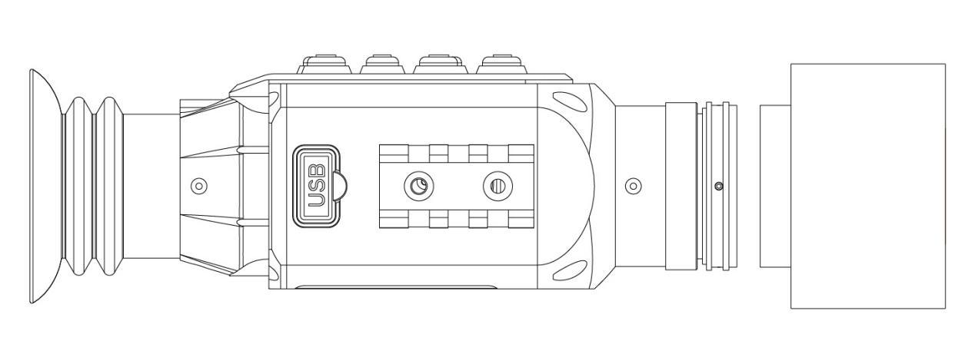

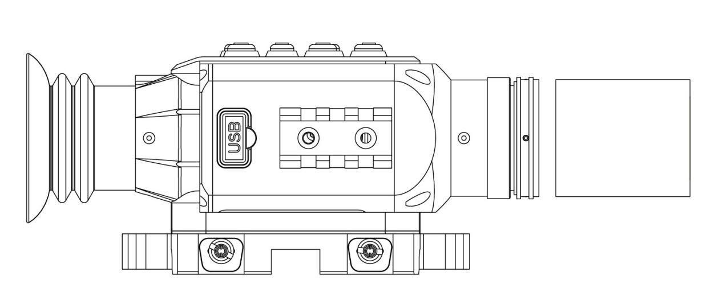

MAINTENANCE AND STORAGE
- The protection grade of the device is IP54.
- Please keep the device in a dry and well-ventilated place. To lengthen the service life, please take out the batteries after every use.
- The battery should not be exposed to direct sun or heat.
- If the front lens is dirty, use the cloth provided to remove dust on the lens surface. Do not blow the lens surface by mouth to prevent saliva particles from smudging the lens surface.
- If the cloth does not thoroughly remove the dust, please prepare absolute ether and absolute ethyl alcohol(ethyl alcohol), mix it at the ratio of 1:1, use the degreasing cotton(medical cotton ball) with the mixture, start from the lens center to the outside of the lens in circular motion, and lightly wipe the lens surface.
- Do not use an old cloth or reused alcohol mixture cotton as a cleaning tool.
- Do not use the glasses cloth, handkerchief, lens tissue or ordinary tissue for wiping.

TROUBLESHOOTING
Some faults or troubleshooting steps during the device’s use process are listed below. Please contact the Accufire directly if there are possible issues beyond what is in this table.
Problem | Possible cause | Corrective action
The device does not start up | Inaccurate battery installation | Ensure the correct battery polarity and reinstall
 | The battery cover is not on correctly | Ensure there is no cross threading of the cover and try to tighten the cover again.
 | The battery cover or the battery compartment’s contact point has oxidation | Clean the contact points
 | Battery power is insufficient or there is one or multiple battery faults | Charge the batteries if rechargeable or replace with new batteries if they are disposable.
Image blurring, strips and uneven situation | Out of calibration | Refer to the compensation mode
 | Buildup on lens | Refer to the maintenance and storage for cleaning
Dark image | Brightness is set too low | Reset the brightness

NOTES

